
Company
Logotype

Cone Beam Computed Tomography- Report



Porur Dental X-rays & CBCT

Patient Name : Mr. Thisainathan | Date of Report : 08.03.2024
Age/ Gender : 40 years/ Male | Region of Interest : CBCT Sectional Mandible
Referring doctor: Dr. Nawazudeen | Indication : Assessment of 46, 47
Clinical Notes: Nil
PATIENT INFORMATION

CBCT- Sectional Mandible provided
CBCT – IMAGE DETAILS

RADIOGRAPHIC INTERPRETATION

- In relation to 46, hyperdense restorative material involving the crown and extending into the root canal upto the apical third is evident.
- In relation to 47, presence of discontinuity of crown structure along the occlusal surface is evident. The line of discontinuity appears to be from the junction of 46, 47 and extends upto the central region just in proximity to the pulp canal.

RADIOGRAPHIC IMPRESSION

- Root canal treated tooth: 46
- Fractured crown in relation to 47.

Kindly correlate with clinical findings


IMAGES FOR REFERENCE

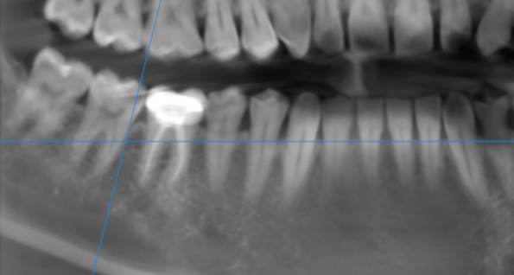

3-DIMENSIONAL VIEW

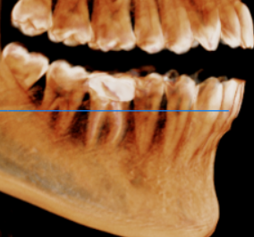

CROSS SECTIONAL VIEW

Discontinuity of crown structure involving the enamel and dentin and in proximity to the pulp canal | 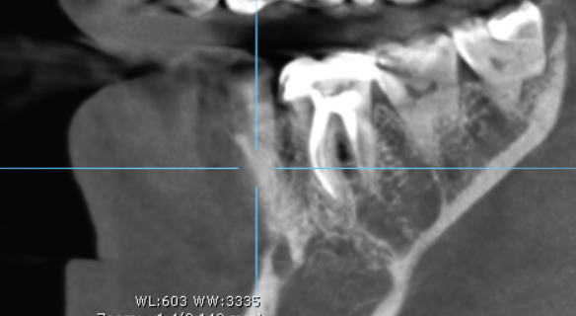

**** End of report ****

